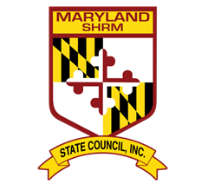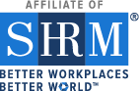

Maryland SHRM State Council
Presents
HR Advocacy Day in Annapolis

January 15, 2020

$35.00 for General Registration
$10.00 for Student Registration
UNIQUE OPPORTUNITY to visit with your state senators/delegates at the opening of the 2020 Legislative Session!!
- Learn about Top Maryland Employment issues
- Advocate as a Chapter
- Take away tips for continuing the advocacy moving forward!
- SHRM Certification Credits provided
Tentative Schedule:
8:00 – 8:30 Continental Breakfast (Meeting Room 170)
8:30 – 10:00 Advocacy Prep: Talking Points & Logistics regarding top bills
10:00 – 11:30 Visits to State Senators and Delegates
11:30 – 12:00 – Advocacy Educational Program (back in the Meeting Room)

Register Here:
https://www.eventbrite.com/e/mdshrm-hr-advocacy-day-2020-tickets-81488762081
Questions? Please email to Cheryl Brown cbrown@darslaw.com
Registration is only available until December 16th, 2020
ONLY 50 spots available - Register Early!

